Distribution of PAHs, PCBs, and PCDD/Fs in products from the full-scale pyrolysis of diverse contaminated organic waste

*Erlend Sørmo1,2, Katinka M. Krahn3, Gudny Øyre Flatabø4,5, Thomas Hartnik6, Hans Peter H. Arp2,7, Gerard Cornelissen2,3\**

1. Norwegian Geotechnical Institute (NGI), 0484 Oslo, Norway
2. Norwegian University of Life Sciences (NMBU), 1430 Ås, Norway
3. Lindum AS, 3036 Drammen, Norway
4. Scanship AS, Nedre Langgate 19, 3126, Tønsberg, Norway
5. University of South-Eastern Norway (USN), Porsgrunn, Norway
6. Norwegian Institute of Bioeconomy Research (NIBIO), 1433 Ås, Norway
7. Norwegian University of Science and Technology (NTNU), 7491 Trondheim, Norway

*Corresponding author contact details: gerard.cornelissen@ngi.no

### Keywords:

Pyrolysis, sewage sludge, organic waste, legacy pollutants, biochar, emission factors

Highlights:

* Organic waste with legacy contaminants pyrolyzed in full-scale system
* Distribution of PAHs, PCBs and PCDD/Fs across pyrolysis products documented
* Emission factors for PAHs and PCDD/Fs in waste organic waste pyrolysis reported
* Net loss of PCBs and PCDD/Fs during pyrolysis confirmed

### Graphical Abstract

Abstract

Pyrolysis may be a better alternative than incineration for handling of contaminated organic wastes, such as sewage sludge due to the potential benefits of pyrogenic carbon capture and storage and value chains related to biochar use. However, questions have been raised about the extent of formation/destruction of legacy contaminants such as polycyclic aromatic hydrocarbons (PAHs), polychlorinated biphenyls (PCBs) and polychlorinated dibenzo dioxins and furans (PCDD/Fs) in the pyrolysis process. Therefore, six organic wastes, including limed and digested sewage sludge, waste timber, garden waste, and food waste reject, were pyrolyzed in a full-scale medium size unit (2-5 kg biochar hr-1) at temperatures between 500 and 800 ˚C. A distribution of PAHs, PCBs, and PCDD/Fs in feedstocks and pyrolysis products (biochar, condensate and flue gas) was established, and demonstrated that removal efficiencies (RE) from the solid matrix was high (>99%) for both PCBs and PCDD/Fs and that the resulting concentrations were below the thresholds suggested by the European Biochar Certificate (EBC). PAH content in the biochar varied between the different feedstock sources and tended to be lower for the chars produced at the highest temperatures but were mostly below EBC thresholds. Furthermore, it was documented that PAHs, PCBs, and PCDD/Fs all accumulate in the condensate, making this product a hazardous waste. Incineration for energy generation is therefore recommended for pyrolysis oils. Emission concentrations for PAHs and PCDD/Fs were mainly associated with particles and were below thresholds set by the European Union for waste incineration, and emission factors (EF) showed that 0.0002 – 78 mg PAHs tonne-1 biochar and 0.002 – 0.45 µg TEQ PCDD/Fs tonne-1 biochar were released during pyrolysis of the various wastes. A mass balance further demonstrated a net loss of 69-90% of PCDD/Fs during pyrolysis, supporting conclusions from previous works that PCDD/F-formation is negligible in high temperature (>500 °C) biomass pyrolysis.

# Introduction

Persistent organic pollutants (POPs) that originate from synthetic chemicals in consumer products distribute into the environment and subsequently concentrate in waste streams including sewage sludge (Cornelissen et al., 2012; Olie et al., 1977; Pereira & Kuch, 2005). Polychlorinated biphenyls (PCBs), polychlorinated dibenzo-p-dioxins and dibenzofurans (PCDD/Fs), and polycyclic aromatic hydrocarbons (PAHs), are groups of legacy pollutants of particular concern due to their persistence, bioaccumulation, and toxicity (Eljarrat & Barceló, 2003). Therefore, there is a need to develop safe methods to treat POP-contaminated waste.

PCBs are well-known for their strong chemical and physical stability, resistance to degradation at high temperatures, low volatility, and electrical resistance, making them ideal for use in electrical equipment (Castro-Jiménez et al., 2008). Polychlorinated dibenzo-p-dioxins and dibenzofurans (PCDD/Fs) are formed unintentionally during the production of chlorinated compounds or during combustion processes. PCDD/Fs are potent carcinogens (White & Birnbaum, 2009) that can be formed during waste incineration and chemical manufacturing (such as herbicides and pesticides) under specific conditions involving high temperature, organic matter, metal catalysts, chlorine, as well as low oxygen levels (Altarawneh et al., 2009; Stanmore, 2004). Polycyclic aromatic hydrocarbons (PAHs) are formed through the incomplete combustion of organic matter, such as fossil fuels, wood, and plastics. They also form easily during waste incineration due to incomplete combustion (Horii et al., 2008).

PCDD/Fs and PCBs up-concentrate in most waste streams such as sewage sludge and other organic waste due to their ubiquitous presence (Stevens et al., 2001). High concentrations of organic pollutants complicate proper waste management due to challenges in the safe removal or stabilization of PCDD/Fs and PCBs. Municipal waste incineration at >1000 ˚C is the standard waste handling strategy for dealing with hazardous contaminated waste streams (Hsu et al., 2021). However, incineration emits greenhouse gases and is energy intensive for wet substrates such as sewage sludge (Samolada & Zabaniotou, 2014). As a result, pyrolysis of sewage sludge has come up as a viable alternative for sewage sludge treatment (Sørmo et al., 2023). This produces biochar, which is a promising solution for the restrictions on use of raw sewage sludge on agricultural fields due to contents of organic pollutants and heavy metals, as well as nutrient enrichment (Cies̈lik et al., 2015). During pyrolysis at high enough temperatures, organic contaminants are expected to evaporate or mineralize, ending up with a biochar product with low levels of contaminants that can be applied as soil amendment in agriculture, as sorbent, or as a component in building materials. In addition to contaminant destruction, biochar production offers the benefit of carbon sequestration (Bolan et al., 2022). However, information is lacking on the fate of compounds like PCBs and PCDD/Fs in full-scale pyrolysis. In addition, concerns exist about PAH contents in sewage sludge biochars, although it holds promise to actually lead to a net reduction of bioavailable PAHs in sewage sludges (Tomczyk et al., 2020).

The EU Health and Environmental Risks and Scientific Committee on Emerging and Newly Identified Health Risks STRUBIAS report includes sewage sludge from the list of prohibited fertilizing products in the EU. However, the STUBIAS report is hesitant about pyrolysis and gasification being a treatment method for removal of organic pollutants (Huygens et al., 2019). Sewage sludge is also banned as feedstock to produce pyrolysis and gasification materials due to the lack of data on the fate of organic pollutants (Moško et al., 2021).

To help solve the uncertainties around the removal of persistent organic pollutants from organic waste and sewage sludge by pyrolysis, several lab-scale studies have been performed (Buss, 2021; Conesa et al., 2009; Moško et al., 2021). Recent work also released the first decomposition data and emission factors for per and polyfluorinated alkyl substances (PFAS) and organophosphorus flame retardants (OPFRs) from waste fractions during pyrolysis in a full-scale pyrolysis unit (Castro et al., 2023; Sørmo et al., 2023).

Despite PCDD/F-formation being associated with waste incineration, particularly when Cl-content in the waste exceeds 1% (Wikström et al., 1996) these compounds are unlikely to form during pyrolysis due to the high temperature and short treatment residence time (Stanmore, 2004). PCDD/Fs are believed to mainly be formed through the de-novo synthesis Deacon-reaction where metal chlorides, especially Cu, form and subsequently release Cl2 that partake in chlorination of the PCDD/Fs (Altarawneh et al., 2009). This has been observed in waste pyrolysis, but with feedstocks containing high Cl (5%) and Cu (3-6%) contents at temperatures <500 °C (Weber & Sakurai, 2001). At higher temperatures (>500 °C) and lower Cl and Cu concentrations PCDD/F-formation through the Deacon-reaction is unlikely due to the limited presence and stability of the relevant Cu-Cl intermediaries (Altarawneh et al., 2009). Indeed, only low levels of PCDD/Fs were found in 50 biochars produced with a wide range of feedstocks (including salty food waste), pyrolysis temperatures and technologies, and no correlation was observed between Cl content in biomass and PCDD/F-contents in the resulting biochars (S. E. Hale et al., 2012). Thus, PCDD/Fs detected in pyrolysis products are expected to derive from the feedstock. However, the primary source of PAHs is expected to form during pyrolysis (Bucheli et al., 2015).

In one of the few studies addressing the fate of legacy POPs during pyrolysis, Moško et al. (2021) found in a lab study that the removal efficiency of PAHs, PCBs and PCDD/Fs increased with increasing pyrolysis temperature, with the highest removal (>97%) observed at 700 °C. The researchers attributed this trend to increased decomposition and transformation of organic pollutants into less toxic forms. Thus, the main knowledge gaps are what happens to PCDD/Fs and PCBs during full-scale pyrolysis, and how many PAHs are formed during the full-scale pyrolysis of sewage sludge. Another knowledge gap is how much PCB and PCDD/F are actually destroyed during pyrolysis, and how much ends up in pyrolysis condensate. In addition, no full mass balance has been established for the full-scale pyrolysis of sewage sludge or similar organic wastes, including the emission of PCBs, PCDD/Fs and PAHs to the air. To this end, we were the first to analyze all pyrolysis products (flue gas, condensate and biochar) to produce a complete mass balance for a full-scale system. Pyrolysis of various sewage sludges, both digested and non-digested, was compared to that of wood-based materials (clean wood chips as a reference and waste timber as a contaminated woody feedstock). Our hypotheses were that i) PCBs and PCDD/Fs are largely destroyed during the full-scale pyrolysis of sewage sludge, and ii) some PAHs are formed during the process. Our work will pave the way to international approval of pyrolysis as a viable way to remove legacy contaminants from organic waste, in particular sewage sludge.

# Materials and methods

The present work was conducted in parallel with another study investigating the fate of per and polyfluorinated alkyl substances (PFAS) during the pyrolysis. The waste fractions investigated, pre-treatments applied, pyrolysis technology and operational conditions used, and sampling strategy are identical to those described by Sørmo et al. (2023). A short summary of these methods is included below.

## Chemicals, waste feedstocks and pre-treatment

Whatman® Glass fiber filters (GFF) and 153 Amberlite® XAD-2® were acquired from Merck (Darmstadt, Germany), while poly urethane foam (PUF) was purchased from VWR (Oslo, Norway). GFFs were pre-cleaned by heating (450 °C, 8 hrs), and XAD and PUF by Soxhlet-extraction with methanol, acetonitrile, toluene (8 hrs for each solvent), and cyclohexane (4 hrs).

Seven waste-derived feedstocks, and one clean wood chips reference material (CWC), were investigated in this study (Table 1). The waste-derived feedstocks were four sludge-based feedstocks (DSS-1, DSS-2, and LSS), one reject from food waste for biogas production (FWR), and two wood-based feedstocks (GW and WT). Each feedstock was dried (≈110 °C, 5-10% moisture) and pelletized (length 40 mm, radius 8 mm) before pyrolysis.

Table 1. Description of the waste material feedstocks studied, conditions for their respective pyrolysis treatments, and sampling information.

|  |  |  |  |  |  |  |
| --- | --- | --- | --- | --- | --- | --- |
| **Feedstock** | **Abbrev.** | **Description** | **Pyrolysis temperatures (˚C)** | **Solid phases sampled** | **Condensate sampled** | **Flue gas sampled** |
| Digested sewage sludge | DSS-1 | Sewage sludge and food waste pre-treated with thermal hydrolysis (170 ˚C) followed by anaerobic digestion for biogas production | 500, 600, 700 and 750 | Yes | Yes (except 500 °C) | Yes (except 750 ˚C) |
| Digested sewage sludge | DSS-2 | Sewage sludge treated by anaerobic digestion for biogas production | 500, 600, 700 and 800 | Yes | No | Yes |
| Limed sewage sludge | LSS | Sewage sludge treated by anaerobic digestion for biogas production, then stabilized/hygenized by addition of lime (39%) | 600 and 700 | Yes | No | Yes |
| Food waste reject from biogas production | FWR | The rejected fraction of food waste before biogas production. Consists of material that does not pass the initial sieving process that removes plastics and other items that are too large or non-digestible | 600 and 800 | Yes | No | Yes |
| Garden waste | GW | Gardening waste from private housholds and businesses. Fraction includes twigs, leaves, roots and some sand/gravel | 500, 600 and 800 | Yes | No | Yes (500 and 800 ˚C) |
| Waste timber | WT | Discarded wood products and objects from private housholds, businesses and construction/demolition (no chemically impregnated wood) | 500, 600, 700 and 800 | Yes | No | Yes |
| Wood chips | CWC | Pellets produced from pine and spruce wood chips from forestry/logging | 500, 600, 700 and 750 | Yes | Yes | Yes |

## Pyrolysis

The feedstock pellets were pyrolyzed using a medium scale Biogreen® pyrolysis unit (2-10 kg biochar hr-1) by ETIA Ecotechnologies, at temperatures between 500 and 800 ˚C and 20 min residence time (Table 1) The pyrolysis gas was channeled into a double jacket, water-cooled condenser unit (10 °C) where pyrolysis condensate was collected through a liquid lock while the syngas was led further to a combustion chamber where it was combusted with propane at 800-900 ˚C before being released as exhaust through a chimney. Gas emission measurements and samples were collected from the chimney during stable temperature conditions.

## Sampling and emission measurements

### Solids sampling

Solids sampling and sample preparation (feedstock, biochar, and condensate) were conducted according to the procedures described in Sørmo et al. (2023). Feedstock and biochar samples were air-dried in the laboratory and crushed in a ball mill (D < 1 mm, Retch ISO 9001) before analysis, while pyrolysis condensate was vigorously shaken to homogenize the oil and water phase before subsampling. Feedstock and biochar samples were characterized for all pyrolysis treatments (Table 1). Pyrolysis condensate was characterized only for CWC and DSS-1 (600, 700 and 750 ˚C).

Biochar yield (Ybiochar %) at each treatment temperature was defined as the rate of biochar produced divided by the feedstock feeding rate over the sampling period.

### Gas emission sampling

Exhaust gas and aerosols were sampled according to the procedure described in Sørmo et al. (2023). Gas measurements were collected for sewage sludge feedstocks, except for CWC (all treatments), DSS-1 (750 ˚C treatment), and GW (600 ˚C treatment). A glass fiber filter (GFF) was used for aerosol collection (0.45 µm), followed by an XAD-2 sorbent for gas phase contaminants from the sludge-based feedstocks, and a PUF sorbent for the wood-based feedstocks.

## Sample preparation and instrumental analysis

Feedstocks, biochar, GFF, PUF and XAD were extracted using accelerated solvent extraction (ASE) and the extracts were analyzed by GC-MS/MS according to ISO 12884 for 16 PAHs, 7 PCBs, and 17 PCDD/Fs (the congeners analyzed are listed in Table S.1). For details, see (Cornelissen et al., 2012). Procedural blanks were taken to analyze background contamination at the sampling site. PAHs were measured in triplicate and PCDD/Fs by single measurements. Samples were analyzed in triplicate for feedstocks and biochar, duplicate for GFF, and single measurements for XAD, PUF and pyrolysis condensate.

## Data analysis

For statistical analyses, LOQ/2 was used in cases where one or two of the replicate data points were < LOQ.

Removal efficiency (RE) was calculated as previously defined by Moško et al. (2021):

|  |  |
| --- | --- |
| $$RE \left(\%\right)=100\%-\left(\frac{C_{biochar}*Y_{biochar}}{C_{feedstock}}\right)$$ | (Eq. 1) |

where *Cbiochar* is the pollutant concentration (ng kg-1) in the biochar produced at a given pyrolysis temperature, *Cfeedstock* is the pollutant concentration (ng kg-1) in the feedstock and *Ybiochar* is the yield (Eq. 1) of the biochar in the pyrolysis process. To be conservative, values below LOQ were set equal to LOQ when calculating removal efficiencies.

Emission factors (EFs) were calculated using the volume of flue gas produced per kg biochar (*Vflue_gas*, m3 kg-1), as estimated through the carbon balance approach (Sørmo et al., 2023):

|  |  |
| --- | --- |
| $$EF_{pollutant}=conc_{pollutant}*V_{flue gas}$$ | (Eq. 2) |

# Results and discussion

## POPs-content in feedstocks

### PCDD/Fs in feedstocks

The total concentration of PCDD/F-17 in toxic equivalents (TEQ; Van den Berg et al., 2006) in the sludge and food waste reject feedstocks were 1.2±0.1, 1.8±0.1, 3.0±0.1, and 8.3±0.2 ng TEQ kg-1 for FWR, DSS-2, LSS, and DSS-1, respectively (Figure 1; Table S.2). These concentrations were in the lower range or below the sum PCDD/F-17 previously found in Norwegian (n=36, 3 - 69 ng TEQ kg-1) (Paulsrud et al., 1997) , UK (n=14, 20–225 ng TEQ kg-1) (Stevens et al., 2001) and Korean (n=11, 0.2 – 49.9 ng TEQ kg-1) (Hwang et al., 2012) sewage sludges. The distribution of PCDD/Fs was similar for the sludge feedstocks and mainly dominated by OCDD (85-91%), followed by 1,2,3,4,6,7,8-HpCDD (6-11%) (Figure S.1). The distribution of PCDD/Fs in FWR was dominated by OCDD (80%), 1,2,3,4,6,7,8-HpCDD (9%), and OCDF (9%).

### PCBs in feedstocks

The total concentration of PCB-7 in the four feedstocks analyzed were 7.6 ± 0.6, 9.2 ± 0.4, 16.6 ± 1.0, and 20.7 ± 0.6 µg kg-1 for DSS-2, FWR, LSS, and DSS-1 (Figure 2; Table S.2). These concentrations are similar to previously reported findings from sewage sludges from MWWTPs in China (n=8, 7.46 – 19.39 µg kg-1) (Guo et al., 2009) and Norway (n=36, 17 – 100 µg kg-1) (Paulsrud et al., 1997). The PCBs were evenly distributed between the seven congeners investigated in the DSS1, DSS-2, and FWR feedstocks, whereas LSS was dominated by PCB52 (60%) respectively (Figure S.2).

### PAHs in feedstocks

PAHs are generally products of incomplete combustion and were thus not expected to be present at high concentrations in the feedstocks. However, all 16 PAHs analyzed for were detected in the feedstocks, except for in the wood chips (CWC), in concentrations ranging from 0.38 ± 0.01 mg kg-1 in food waste reject (FWR) to 5.05 ± 0.09 mg kg-1 in waste timber (WT) (Figure 3; Table S.2). These concentrations are in the same range as those found in 36 different Norwegian sewage sludges (range 0.7-30, median 3.9 mg kg-1) (Paulsrud et al., 1997). The distribution of PAH congeners in each feedstock is shown in .3

## POPs-content in biochars

### PCDD/Fs in biochars

Concentrations of ∑PCDD/F-17 in the biochar samples (Figure 1; Table S.2) ranged between 0.003 ng TEQ kg-1 in DSS-1-800 to 0.07 ng TEQ kg-1 in FWR-600 and were thus 2-3 orders of magnitude lower than those in the original feedstocks (details on removal efficiency in Section 3.3, Table 2). There was no significant (p>0.05) linear relationship between reduction in PCDD/F-concentration and pyrolysis temperature. However, for FWR, the concentration of PCDD/Fs decreased by one order of magnitude from 600 to 800 ˚C whereas for the two other feedstocks (DSS-1 and DSS-2) it stayed within the same order of magnitude for all temperatures (except for DSS-1-800 that dropped one order).

Pyrolysis reduced the variety of PCDD/F congeners – the biochar samples contained 43-86 % fewer congeners (average 72 ± 13%) than their feedstock materials (Table S.3; Figure S.4). The most persistent PCDD/Fs toward thermal volatilization/degradation was 1,2,3,4,6,7,8-HpCDD which was found in all feedstocks and biochar samples at each temperature. OCDD was found in 90% of the biochars. Overall, the HxCDFs, HxCDDs, PeCDFs and PeCDDs were most easily removed from the solid matrix (feedstock/biochar) (see section 3.3. for further details).

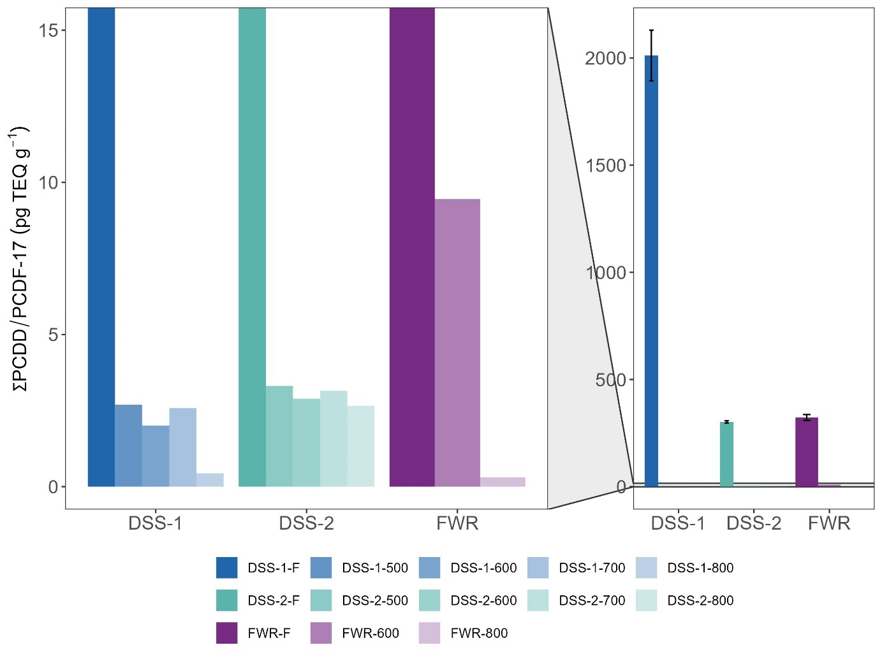

Figure 1 Total PCDD/F concentrations as toxic equivalents (ng TEQ kg-1) before and after pyrolysis treatment at increasing temperatures (500-800 °C) for the different feedstocks tested.

### PCBs in biochars

Concentrations of ∑PCB-7 in the biochar samples ranged from <LOQ (DSS-1-600) to 1.7 µg kg-1 (DSS-1-500) and were thus 1-2 orders of magnitude lower than those in the original feedstocks (details on removal efficiency in Section 3.3, Table 3). All biochar samples were below the European Biochar threshold for premium quality biochar of <0.2 mg kg-1 (EBC, 2022). There was no significant (p>0.05) linear relationship between reduction in PCB concentration and pyrolysis temperature. However, for DSS-1, the concentration of PCBs decreased from 500 to 700 to 800 ˚C (<LOQ at 600 ˚C). The other feedstocks (DSS-2 and LSS) were within the same order of magnitude for all temperatures.

Pyrolysis reduced the variety of PCB congeners – the biochar samples contained 14-100% fewer congeners (average 59 ± 25%) than their feedstock materials (Table S.3). The most abundant PCB in the biochars was PCB153, which was found in 90% of the biochars at all temperatures, while PCB180 was not detected in any of the biochar samples.

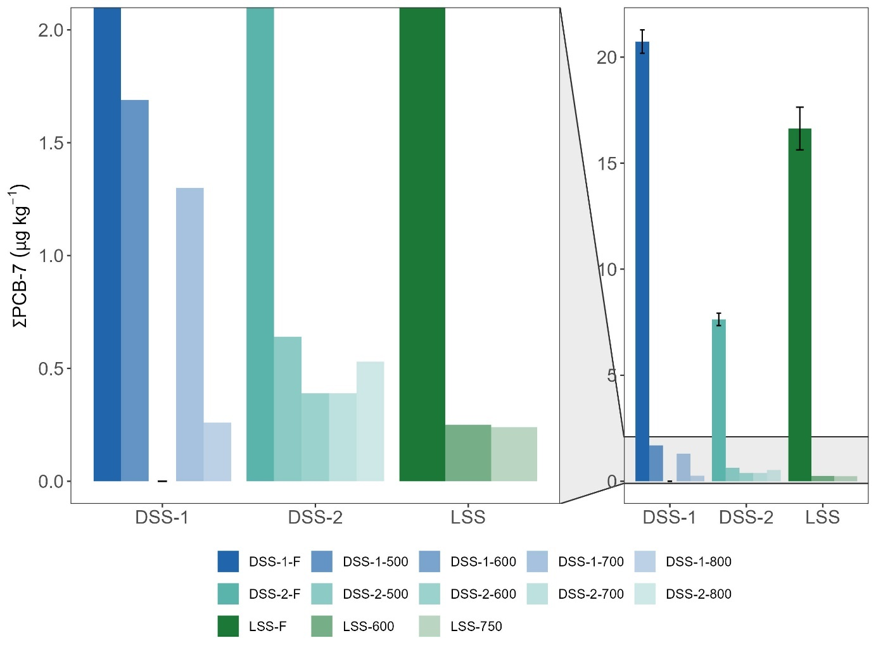

Figure 2 Total PCB-7 concentrations (µg kg-1) before and after pyrolysis treatment at increasing temperatures for the different feedstocks tested.

### PAHs in biochars

Mean ∑PAH-16 concentration and range for all temperatures and feedstocks was 16±24 mg kg-1, and 2.5 – 118 mg kg-1 respectively (Figure 3; Table S.2). Small variations were observed between feedstocks pyrolyzed (Figure 3), but there was no significant correlation (R2 = 0.009, p = 0.25 ) between pyrolysis temperature and biochar PAH-concentration. The highest PAH-16 concentrations overall were found for waste timber (WT) where WT-600 contained 118 ± 5 mg kg-1 ∑PAH-16. This is well above the EBC limit value for EBCAgro, biochar certified for use in agriculture, of 6 mg kg-1 (EBC, 2022), and much higher than (Sørmo et al., 2020) reported (14 ± 5 mg kg-1) for waste timber pyrolyzed at 600 ˚C in a medium-scale Pyreg 500 unit. Previous studies have both observed positive (Rogovska et al., 2012), negative (S. E. Hale et al., 2012), and non-significant correlations (Kloss et al., 2012) between biochar PAH-concentrations and pyrolysis temperature. Increasing residence time in the pyrolysis reactor has also been found to lower biochar PAH-concentrations (S. E. Hale et al., 2012). However, PAH concentrations will also vary with different feedstocks pyrolyzed (S. Hale et al., 2011; Rogovska et al., 2012), and the technological setup of the pyrolyzing unit that allow for a quick separation of pyrolysis gas and biochar and a slower cooling of the biochar might get biochars with low PAH-concentrations by avoiding condensation of evaporated PAHs (Sørmo et al., 2020).

Seven of 23 samples were below the European Biochar Certificate (EBC) limit for EBC-Agro, AgroOrganic and FeedPlus, which is <6 mg kg-1 for ∑16 EPA PAH (EBC, 2022): DSS-1-800, DSS-2-700, GW-600, LSS-600, LSS-750, WT-500, and WT-800. 18 of 23 biochar samples were below the ∑8 EFSA PAH limit of 1 mg kg-1. The total concentration of PAHs and PCDD/Fs in biochar may, however, not accurately reflect their bioavailability, as their high hydrophobicity renders them non-leachable. PAHs are known to bond via π-π interactions with aromatic rings in the condensed, aromatic rings of the biochar matrix, thereby enhancing their sorption onto the biochar surface (S. E. Hale et al., 2012). A similar effect is also assumed to apply for the PCDDFs and PCBs that are known to strongly bind to black carbon matrices including biochar (Cornelissen et al., 2005, 2008).

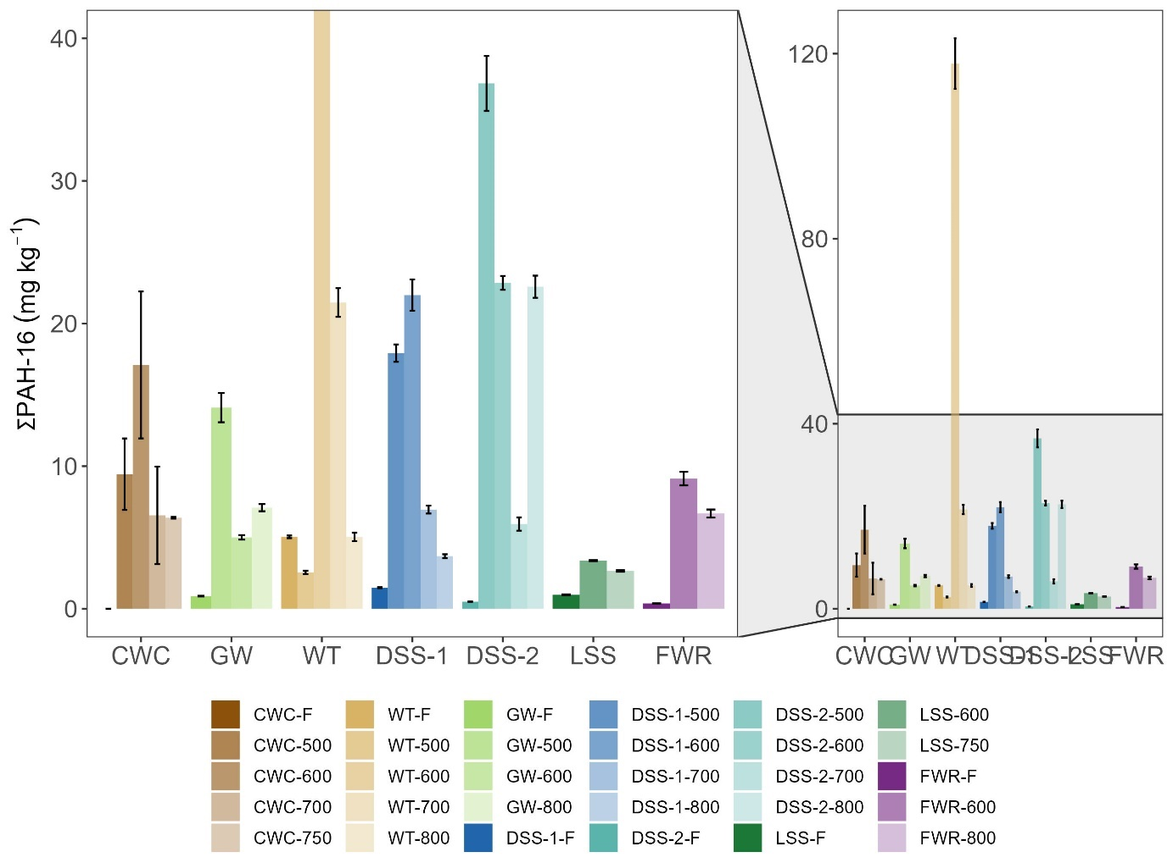

Figure 3 Total PAH-16 concentrations (mg kg-1) before and after pyrolysis treatment at increasing temperatures for the different feedstocks tested.

## Removal efficiencies

Removal of PCDD/Fs

Removal efficiencies (RE) for ∑PCDD/PCDF-17 were >99.9% across all pyrolysis temperatures and feedstocks (Table 2). Note that RE (Eq. 1) is corrected for biochar yield to account for mass reduction (yields in Table S.4). As PCDD/Fs are not expected to be formed during pyrolysis, the initial concentrations in the feedstocks are therefore the basis for calculation of removal efficiencies and mass balances. Similar to previous observations (S. E. Hale et al., 2012), there was no statistically significant relationship (p>0.05) between chlorine content in the feedstocks and distribution of PCDD/Fs in the pyrolysis products (Cl-content in feedstock in Table S.4).

The reduction of PCDD/Fs in the biochar, compared to feedstock, is probably a result of the two following mechanisms: 1) volatilization to the pyrolysis gas, and 2) thermal decomposition. (Hu et al., 2007) found that only OCDD at 0.5 pg TEQ kg-1 was detected in char from pyrolysis (800 ˚C, 60 min) of sediments contaminated with 17 PCDD/F-congeners (71 ng TEQ kg-1). This residual concentration is five to six orders of magnitude lower than the biochar concentrations in the present study, however, we still observed similar removal efficiencies (>99%). Hu et al. (2007) furthermore proposed that volatilization was the main mechanism of removal for PCDD/Fs. This hypothesis is supported in the present work as high concentrations were found in pyrolysis condensates (see section 3.3 for more. details). The dominating presence of HpCDD and OCDD residuals in the biochars (Table S.4) is therefore most likely a result of these congeners having the highest boiling points (507 and 510 °C respectively) and a resulting distillation effect between the solid phase and condensate/gas (Weber & Sakurai, 2001).

### Removal of PCBs

As for the PCDD/Fs, the REs for ΣPCB-7 were >99% across all feedstocks and pyrolysis temperatures. Previously reported removal efficiencies were observed to increase with increasing pyrolysis temperature, with the highest removal efficiency of >97% for PCBs observed at 700 degrees °C (Moško et al., 2021). These authors noted that the removal efficiency was significantly influenced by the pyrolysis temperature and the molecular structure of the PCBs (Moško et al., 2021). No relationship between RE and degree of chlorination was, however, found in the present work. High removal efficiencies of >99.99% has furthermore also been documented for dioxin-like PCBs in pyrolysis (800 °C) of contaminated sediments (Hu et al., 2007). Thermal decomposition of PCBs has been demonstrated to occur between 250 and 370 °C in the pyrolysis of circuit boards (Evangelopoulos et al., 2015), corroborating the current and previous findings of high PCB-REs in pyrolysis >500 °C. The formation of dioxin-precursors as a result of the thermal destruction of PCB has been raised as a potential drawback for waste pyrolysis (Evangelopoulos et al., 2015), but in the present work a net destruction of PCDD/Fs was observed rather than formation (see section 3.4).

### Implications

The present work has demonstrated that a pyrolysis temperature of 500 ˚C is likely sufficient to remove nearly 100% of the PCDD/Fs and PCBs from sewage sludge and other organic waste feedstocks. In parallel studies, removal efficiencies of >99.5% were reported for organophosphate flame retardants (OPFRs) in the DSS-1and LSS feedstocks pyrolyzed at 500-600 ˚C (Castro et al., 2023) and >98.3 % for per- and polyfluoroalkyl substances (∑PFAS-56) in the DSS-1, DSS-2, FWR, and LSS feedstocks pyrolyzed at 500-800 ˚C (Sørmo et al., 2023). These studies demonstrate that most organic contaminants are likely to be volatilized/decomposed from the solid phase in full-scale pyrolysis systems.

Table 2. Removal efficiency % (RE) of PCB-7 and PCDD/PCDF-17 in TEQ by pyrolysis of waste feedstocks at temperatures 500-800 °C normalized for yield biochar.

|  |  |  |  |
| --- | --- | --- | --- |
| **Feedstock** | **Pyr. temp. (˚C)** | **% RE** | |
| **∑PCB-7** | **∑PCDD/PCDF-17 (TEQ)** |
| DSS-1 | 500 | 99.97 | 99.99 |
| 600 | 99.95 | 99.99 |
| 700 | 99.97 | 99.99 |
| 800 | 99.95 | 99.99 |
| DSS-2 | 500 | 99.94 | 99.96 |
| 600 | 99.93 | 99.95 |
| 700 | 99.94 | 99.96 |
| 800 | 99.94 | 99.96 |
| FWR | 600 | n.d. | 99.94 |
| 800 | n.d. | 99.96 |
| LSS | 600 | 99.97 | n.d. |
| 750 | 99.97 | n.d. |

n.d. = pollutant not detected in biochar sample.

## Emission factors

PCDD/F and PAH emission concentrations, emission factors (EF), and their distribution between the particle and gas phase of the flue gas, for each feedstock and treatment temperature are presented in Table 3.

### Emission factors of PCDD/Fs

Emission concentrations of PCDD/Fs ranged between LOQ and 2.7 pg TEQ Nm−3 and were highest for the DSS-2 feedstock (0.15 – 2.7 pg TEQ Nm−3) and lowest for the DSS-1 feedstock (<LOQ) (Table 3). The emission concentrations were 2-3 orders of magnitude lower than the EU emission standard (0.1 ng I-TEQ Nm−3) (Paradiz & Dilara, 2003) and four to five orders of magnitude lower than that observed from a Dutch municipal solid waste incineration plant (53 ng TEQ Nm-3 (Matthijsen et al., 1991).

EFs for PCDD/Fs ranged from <LOQ to 0.45 µg TEQ tonne-1 and emission concentrations ranged from <LOQ to 41 pg m-3. PCDD/Fs emissions were primarily associated with aerosols, 77-100% of the total PCDD/Fs in the exhaust were detected on the collected particles. This trend is expected for such hydrophobic compounds (Wang et al., 2011).

The relatively low emission concentrations and EFs of PCDD/Fs in the present work are likely due to a large fraction of PCDD/Fs being sequestered in the condensates (see section 3.3) and due the high O2-concentration (>11 %) in the combustion chamber of the pyrolysis unit used, that likely favors decomposition of PCDD/Fs (Altarawneh et al., 2009).

### Emission factors PAHs

Emission concentrations of ∑PAH-16 ranged between 0.22 and 421 µg Nm-3 across all feedstocks and pyrolysis temperatures (Table 3). There was no correlation between pyrolysis temperature and emission concentrations, and low (<1 µg Nm-3) and high (>100 µg Nm-3) concentrations were recorded for both the sludge and wood-based feedstocks. Only two feedstock and temperature combinations (CWC-700 = 137 µg Nm-3 and DSS-2-500 = 421 µg Nm-3) resulted in emission concentrations above the Dutch air regulations for asphalt mixing plants of 0.05 mg ∑PAH-16 Nm-3 (Rijkswaterstaat, 2023). It is speculated that the high PAH emission concentrations (>100 µg Nm-3) documented are more related fluctuating conditions in the combustion chamber rather than a specific feedstock and pyrolysis temperature combination. It is noteworthy to add that on average, pyrolyzing the clean reference feedstock, did not lead to lower emissions than the contaminated feedstocks, except for the DSS-2 feedstock.

EFs for ΣPAH-16 ranged from 0.00023 to 78 mg tonne-1 (Table 3). A previously measured EF for WT at 600 °C in a Pyreg-500 pyrolysis unit (20 ± 0.2 mg tonne-1) was similar to the recorded EF in the present study (11 mg tonne-1) for the same feedstock at the same temperature (Sørmo et al., 2020). In that study, the authors reported that gas-phase-PAHs accounted for 43 ± 22% of the emitted PAHs and that the small PAHs (2-3 rings) were mainly found in this phase. In the present work, the gas phase PAH-fraction was higher (70-100% of the total emissions), but the distribution of small (2-3 rings) and large (4-6 rings) PAHs (number of PAH rings in Table S. 1) between the gas and particle phase respectively, was the same as reported by (Sørmo et al., 2020). The dominance by small PAHs and gas phase emissions could be a result of conditions in the combustion chamber favoring more complete combustion (high O2 concentration and temperature). The observed distribution is a positive effect, as the carcinogenic PAHs were mainly found in the less significant particle fraction (31 % of the total).

Table 3 Emission concentrations and emission factors of PAH-16 and PCDD/F-17 and the respective toxic equivalents (TEQ) detected in flue gas from the pyrolysis of sewage sludge (DSS-1, DSS-2, LSS), wood-based feedstocks (WT, GW, and CWC) and reject (FWR) pyrolyzed at the temperatures specified, along with the relative fractions of ∑PAH-16 and ∑PCDD/F-17 found in the gaseous and particle-based fractions (%). The values are normalized to mg or µg per tonne biochar produced.

|  |  |  |  |  |  |  |  |  |  |  |  |  |  |  |  |  |  |  |  |  |
| --- | --- | --- | --- | --- | --- | --- | --- | --- | --- | --- | --- | --- | --- | --- | --- | --- | --- | --- | --- | --- |
| ***PAH-16*** | | | | | | | | | | | | | | | | | | | | |
|  | **DSS-1** | | | **DSS-2** | | | | **FWR** | | **LSS** | | **WT** | | | | **CWC** | | | **GW** | |
|  | **500** | **600** | **700** | **500** | **600** | **700** | **800** | **600** | **800** | **600** | **750** | **500** | **600** | **700** | **800** | **500** | **600** | **700** | **500** | **800** |
| **Emission concentration (µg Nm-3)** | 1.7 | 3.2 | 1.6 | 421 | 21 | 2.4 | 5.1 | 2.3 | 1.4 | 2 | 6 | 1.4 | 0.27 | 0.41 | 2.0 | 0.31 | 0.22 | 137 | 0.27 | 0.41 |
| **Emission factor (mg tonne-1)** | 0.0022 | 0.0069 | 0.0026 | 3.7 | 0.0741 | 0.0060 | 0.029 | 0.0031 | 0.010 | 0.0095 | 0.022 | 78 | 11 | 26 | 42 | 0.00032 | 0.00023 | 1.9 | 0.00040 | 0.00049 |
| **Particles (%)** | 0 | 0 | 0 | 14 | 16 | 5 | 6 | 17 | 12 | 14 | 6 | 16 | 2 | 10 | 11 | 7 | 14 | 30 | 0 | 0 |
| **Gaseous (%)** | 100 | 100 | 100 | 86 | 84 | 95 | 94 | 83 | 88 | 86 | 94 | 84 | 98 | 90 | 89 | 93 | 86 | 70 | 100 | 100 |
| ***PCDD/F-17*** | | | | | | | | | | | |  |  |  |  |  |  |  |  |  |
|  | **DSS-1** | | | **DSS-2** | | | | **FWR** | | **LSS** | |  |  |  |  |  |  |  |  |  |
|  | **500** | **600** | **700** | **500** | **600** | **700** | **800** | **600** | **800** | **600** | **750** |  |  |  |  |  |  |  |  |  |
| **Emission concentration (pg Nm-3)** | <LOQ | <LOQ | <LOQ | 41 | 13 | 3.1 | 38 | <LOQ | 16 | 1.3 | 21 |  |  |  |  |  |  |  |
| **Emission concentration (pg TEQ m-3)** | <LOQ | <LOQ | <LOQ | 2.7 | 0.6 | 0.15 | 2.2 | <LOQ | 1.6 | 0.10 | 1.5 |  | |  |  |  |  |  |  |  |
| **Emission factor (µg tonne-1)** | <LOQ | <LOQ | <LOQ | 0.52 | 0.75 | 0.08 | 1.2 | <LOQ | 0.90 | 0.03 | 6.2 |  | |  |  |  |  |  |  |  |
| **Emission factor (µg TEQ tonne-1)** | <LOQ | <LOQ | <LOQ | 0.03 | 0.04 | 0.004 | 0.07 | <LOQ | 0.09 | 0.002 | 0.45 |  | |  |  |  |  |  |  |  |
| **Particles (%)** | <LOQ | <LOQ | <LOQ | 100 | 100 | 100 | 100 | <LOQ | 77 | 100 | 86 |  | |  |  |  |  |  |  |  |
| **Gaseous (%)** | <LOQ | <LOQ | <LOQ | 0 | 0 | 0 | 0 | <LOQ | 23 | 0 | 14 |  | |  |  |  |  |  |  |  |

LOQ PCDD/F-17 = 0.5-5 pg m-3

## POP mass balances; Distribution over air, biochar and condensate

Table 4 shows a mass balance for PAHs and PCDD/Fs, which is their distribution between the different pyrolysis products at the various temperatures. Note that the total concentrations in Table 4 are different from those reported for the remaining results because they have been normalized for yield of each pyrolysis product in order construct a representative mass balance. Measured concentrations are provided in Table S.5.

### PCDD/Fs

Based on total feedstock concentrations, 95.9-99.8% PCDD/F-17 partitioned into the pyrolysis condensate, while 0.1-4% were in the biochar, and <0.12% were emitted in the gaseous phase (Table 4). PCDD/F-17 concentrations in the pyrolysis condensate were as high as 1241 ng kg-1 for DSS-1-600 (50 ng TEQ kg-1) and 16 and 1.8 ng TEQ kg-1 for FWR-800 and DSS-1-600, respectively (Table S.5). Furthermore, unlike the hepta and octachlorinated PCDD/Fs, the tetra, penta and hexachlorinated PCDD/Fs almost entirely partitioned from the solid phase into the condensate, corroborating the distillation effect based on the PCDD/F-boiling points observed by Weber & Sakurai (2001). In addition, PCDFs not present in the feedstocks, appeared in the condensate and PCDFs rather than PCDDs dominated the flue gas emissions, suggesting transformations of PCDDs to PCDFs through reactions with H2 produced during the pyrolysis (Altarawneh et al., 2009). The mass balance shows that the total amounts of PCDDFs in the condensate, biochar, and emission gases combined were 69-90% lower than the original feedstock concentrations (Table 4), implying that some PCDD/Fs may also have been destroyed or dechlorinated. A complete understanding of the thermal degradation of PCDD/Fs is lacking, but both dechlorination and destruction through reaction with O2 can take place, with the latter believed to be the dominant degradation pathway (Chen et al., 2020). Hence, these results partly confirm hypothesis 1. However, TEQ-based PCDD/F-17 levels were observed to increase for two of the three feedstocks tested, DSS-1 and FWR (Table 6). This probably indicates that some PCDD/Fs had been transformed to more toxic congeners during pyrolysis. We hypothesize that it is mainly due to dechlorination of the octa-chlorinated OCDD/F (by far the most abundant congener, at over 2000 ng g-1 (Table SX), but with a low TEQ factor of 0.001) into the far more toxic tetra- and penta-substituted congeners with TEQ of 0.1 or 1.

### PAHs

Table 4 shows how ∑PAH-16 are distributed between the different pyrolysis products for wood chips (CWC) and digested sewage sludge 1 (DSS-1) at different temperatures. For CWC and DSS-1, >98% of ∑PAH-16 end up in the pyrolysis condensate except for CWC-700 on which 63% of the PAHs are in the condensate and 37% are emitted in the exhaust. Measured PAH-16 concentrations in the pyrolysis condensate ranged from 800 – 2600 g kg-1 from DSS-1-800 and CWC-600, respectively (Table S.5) and this fraction has thus the potential to be regarded as hazardous waste (∑PAH-16 >1 %) (European Commission, 2014). Less than 0.3% PAHs were emitted via the gas phase, whereas 0.04-1.33 % PAHs ended up in the biochar. Since the PAH-content in the feedstocks were low or below detection limits (<LOQ for CWC and 1.48 mg kg-1 for DSS-1), this confirmed the second hypothesis that PAHs are formed during pyrolysis, in accordance with what is expected during incomplete combustion processes (Buss et al., 2022). The Biogreen unit is designed to achieve a rapid separation of pyrolysis gas and biochar to avoid recondensation of compounds volatilized from the solid matrix, such as PAHs. Volatilized PAHs thus exit the pyrolysis reactor to be condensed into the pyrolysis oil or emitted with the flue gas. Most of the PAHs partition into the condensate rather than the flue gas because of the high affinity of hydrophobic PAH (high *K*OW) (Jesus et al., 2022) or the organic oil fraction that dominates pyrolysis condendates (Papari & Hawboldt, 2018).

### PCBs

A total mass balance was not conducted for PCBs because PCBs were not measured in the gaseous phase. ΣPCB-7-concentrations in the pyrolysis condensate were 22, 106, and 113 µg kg-1 for DSS-2-600, LSS-600, and DSS-1-600, respectively (Table S.5). Excluding the gaseous phase, 0-3% of PCBs was retrieved in the biochar, and 99-100 % in the condensate (Table S.6). This suggests the PCBs follow a similar trend to the PCDD/Fs.

Table 4 Distribution of ∑PAH-16 and ∑PCDD/F-17 in biochar, pyrolysis condensate, and exhaust (particles and gas). The distribution is normalized to the amount of feedstock used to produce the corresponding product fractions and normalized for yield of each pyrolysis product. The mass balance deviation is the difference in percent between the total PCDD/F-concentration in the feedstock and the summed concentration in the pyrolysis products to estimate PAH and PCDD/F formation/degradation.

|  |  |  |  |  |  |  |  |  |  |  |
| --- | --- | --- | --- | --- | --- | --- | --- | --- | --- | --- |
| **PAH-16** |  | **∑PAH-16 concentration** | | | | | **% ∑PAH-16 distribution** | | | **Mass balance deviation** |
|  |  | **mg kg-1** | | | | | **%** | | | **Sum PAH-16** |
| **feedstock** | **Pyr. temp. ˚C** | **feedstock** | **biochar** | **exhaust** | **oil** | **total** | **biochar** | **exhaust** | **oil** | **Biochar + exhaust + condensate** |
| CWC | 500 | <LOQ | 1.7 | 3.0 | 1191 | 1195 | 0.14 % | 0.25 % | 99.61 % | + 100% |
| 600 | 3.37 | 1.9 | 2627 | 2632 | 0.13 % | 0.07 % | 99.80 % |
| 700 | 1.3 | 1317 | 2204 | 3522 | 0.04 % | 37.39 % | 62.57 % |
| DSS-1 | 600 | 1.48 | 13 | 3.1 | 946 | 962 | 1.33 % | 0.32 % | 98.34 % | + 650% |
| 700 | 4.3 | 1.2 | 801 | 807 | 0.53 % | 0.14 % | 99.32 % | + 545% |
| **PCDD/F** |  | **∑PCDD/F-17**  **Concentration** | | | | | **% ∑PCDD/F-17**  **distribution** | | | **Mass balance deviation** |
|  |  | **µg TEQ kg-1** | | | | | **%** | | | **TEQ PCDD/F** |
| **feedstock** | **Pyr. temp. ˚C** | **feedstock** | **biochar** | **exhaust** | **oil** | **total** | **biochar** | **exhaust** | **oil** | **Biochar + exhaust + condensate** |
| DSS-1 | 600 | 8.3 | 0.005 | <LOQ | 10.99 | 11.00 | 0.43 % | <LOQ | 99.57 % | + 33% |
| DSS-2 | 600 | 1.8 | 0.01 | 0.002 | 0.45 | 0.46 | 4.03 % | 0.12 % | 95.86 % | - 26% |
| FWR | 800 | 1.2 | 0.001 | 0.01 | 3.53 | 3.54 | 0.10 % | 0.10 % | 99.79 % | + 300% |
|  |  | **µg kg-1** | | | | | **%** | | | **Sum PCDD/F** |
| **feedstock** | **Pyr. temp. ˚C** | **feedstock** | **biochar** | **exhaust** | **oil** | **total** | **biochar** | **exhaust** | **oil** | **Biochar + gas + condensate** |
| DSS-1 | 600 | 2011 | 1.17 | <LOQ | 270.46 | 271.63 | 0.43 % | <LOQ | 99.57 % | - 86% |
| DSS-2 | 600 | 302 | 1.24 | 0.04 | 29.61 | 30.89 | 4.03 % | 0.12 % | 95.86 % | - 90% |
| FWR | 800 | 323 | 0.10 | 0.10 | 98.74 | 98.95 | 0.10 % | 0.10 % | 99.79 % | - 69% |

# Conclusions

PCDD/Fs and PCBs were mostly eliminated from the biochars (>99.9% removal efficiencies), but not all contamination were completely destroyed, as 10-30% of PCDD/Fs ended up in the condensate, partly transformed into more toxic congeners. PAHs might accumulate in some biochars (differences between feedstocks and possibly temperatures), but the design of the unit can reduce their presence.

Our study shows that pyrolysis condensates are toxic and potentially hazardous waste due to their high concentrations of PAHs, PCBs and PCDD/Fs. This warrants proper safe handling and high-temperature incineration as an end-of-chain solution. This problematic condensate fraction indicates that it could be an advantage with regard to POP-handling to operate a pyrolysis unit with direct combustion of the pyrolysis gas. Further work should focus on the mass balance of PCDD/Fs and PCBs in such units and answer the question whether all POPs are destroyed during pyrolysis and after-combustion, or whether higher amounts of POPs end up in the biochar or are emitted through the chimney with the gaseous fractions.

Dioxin emissions from the presently studied unit were observed to be very low, despite having some feedstocks with relatively high Cl contents (e.g., FWR: 0.26±0.02 %). PAH emissions were mostly particle-bound (70-100%), and total emission concentrations of ∑PAH-16 were below the suggested industrial limit of 0.05 mg Nm-3 (Rijkswaterstaat, 2023). This suggests that flue gas cleaning is not necessarily needed with regard to POP contents.

Supporting Information

Supplementary data associated with this article can be found here x.

Acknowledgements

The authors acknowledge funding from the Research Council of Norway, mainly through the joint-industry sustainability (BIA-X) project “Valorization of Organic Waste” (VOW) (NFR 299070) whereof Lindum AS (stakeholder in sorbent application), the Norwegian Geotechnical Institute (research institute and project leader), and Scanship (technology supplier) played the key roles for generating the test material and data for this manuscript.

References

Altarawneh, M., Dlugogorski, B. Z., Kennedy, E. M., & Mackie, J. C. (2009). Mechanisms for formation, chlorination, dechlorination and destruction of polychlorinated dibenzo-p-dioxins and dibenzofurans (PCDD/Fs). *Progress in Energy and Combustion Science*, *35*(3), 245–274. https://doi.org/10.1016/J.PECS.2008.12.001

Bolan, N., Hoang, S. A., Beiyuan, J., Gupta, S., Hou, D., Karakoti, A., Joseph, S., Jung, S., Kim, K.-H., & Kirkham, M. B. (2022). Multifunctional applications of biochar beyond carbon storage. *International Materials Reviews*, *67*(2), 150–200.

Bucheli, T. D., Hilber, I., & Schmidt, H.-P. (2015). Polycyclic aromatic hydrocarbons and polychlorinated aromatic compounds in biochar. In *Biochar for environmental management* (pp. 627–656). Routledge.

Buss, W. (2021). Pyrolysis solves the issue of organic contaminants in sewage sludge while retaining carbon—making the case for sewage sludge treatment via pyrolysis. *ACS Sustainable Chemistry & Engineering*, *9*(30), 10048–10053.

Buss, W., Hilber, I., Graham, M. C., & Mašek, O. (2022). Composition of PAHs in biochar and implications for biochar production. *ACS Sustainable Chemistry & Engineering*, *10*(20), 6755–6765.

Castro, G., Sørmo, E., Yu, G., Sait, S. T. L., González, S. V, Arp, H. P. H., & Asimakopoulos, A. G. (2023). Analysis, occurrence and removal efficiencies of organophosphate flame retardants (OPFRs) in sludge undergoing anaerobic digestion followed by diverse thermal treatments. *Science of The Total Environment*, *870*, 161856.

Castro-Jiménez, J., Deviller, G., Ghiani, M., Loos, R., Mariani, G., Skejo, H., Umlauf, G., Wollgast, J., Laugier, T., Héas-Moisan, K., Léauté, F., Munschy, C., Tixier, C., & Tronczyński, J. (2008). PCDD/F and PCB multi-media ambient concentrations, congener patterns and occurrence in a Mediterranean coastal lagoon (Etang de Thau, France). *Environmental Pollution*, *156*(1), 123–135. https://doi.org/10.1016/J.ENVPOL.2007.12.019

Chen, Z., Zhang, S., Lin, X., & Li, X. (2020). Decomposition and reformation pathways of PCDD/Fs during thermal treatment of municipal solid waste incineration fly ash. *Journal of Hazardous Materials*, *394*, 122526.

Cies̈lik, B. M., Namies̈nik, J., & Konieczka, P. (2015). Review of sewage sludge management: standards, regulations and analytical methods. *Journal of Cleaner Production*, *90*, 1–15. https://doi.org/10.1016/J.JCLEPRO.2014.11.031

Conesa, J. A., Font, R., Fullana, A., Martin-Gullon, I., Aracil, I., Gálvez, A., Moltó, J., & Gómez-Rico, M. F. (2009). Comparison between emissions from the pyrolysis and combustion of different wastes. *Journal of Analytical and Applied Pyrolysis*, *84*(1), 95–102.

Cornelissen, G., Amstaetter, K., Hauge, A., Schaanning, M., Beylich, B., S. Gunnarsson, J., D. Breedveld, G., M.P. Oen, A., & Eek, E. (2012). Large-Scale Field Study on Thin-Layer Capping of Marine PCDD/F-Contaminated Sediments in Grenlandfjords, Norway: Physicochemical Effects. *Environmental Science &amp; Technology*, *46*(21), 12030–12037. https://doi.org/10.1021/es302431u

Cornelissen, G., Cousins, I. T., Wiberg, K., Tysklind, M., Holmström, H., & Broman, D. (2008). Black carbon-dominated PCDD/Fs sorption to soils at a former wood impregnation site. *Chemosphere*, *72*(10), 1455–1461.

Cornelissen, G., Gustafsson, Ö., Bucheli, T. D., Jonker, M. T. O., Koelmans, A. A., & Van Noort, P. C. M. (2005). Extensive sorption of organic compounds to black carbon, coal, and kerogen in sediments and soils: Mechanisms and consequences for distribution, bioaccumulation, and biodegradation. In *Environmental Science and Technology* (Vol. 39, Issue 18, pp. 6881–6895). https://doi.org/10.1021/es050191b

EBC. (2022). European Biochar Certificate - Guidelines for a Sustainable Production of Biochar. *Carbon Standards International (CSI), Frick, Switzerland*, *10.2*.

Eljarrat, E., & Barceló, D. (2003). Priority lists for persistent organic pollutants and emerging contaminants based on their relative toxic potency in environmental samples. *TrAC Trends in Analytical Chemistry*, *22*(10), 655–665. https://doi.org/10.1016/S0165-9936(03)01001-X

European Commission. (2014). Commission Regulation (EU) No 1357/2014 of 18 December 2014 replacing Annex III to Directive 2008/98/EC of the European Parliament and of the Council on waste and repealing certain Directives Text with EEA relevance. *Official Journal of the European Union*.

Evangelopoulos, P., Kantarelis, E., & Yang, W. (2015). Investigation of the thermal decomposition of printed circuit boards (PCBs) via thermogravimetric analysis (TGA) and analytical pyrolysis (Py–GC/MS). *Journal of Analytical and Applied Pyrolysis*, *115*, 337–343.

Guo, L., Zhang, B., Xiao, K., Zhang, Q., & Zheng, M. (2009). Levels and distributions of polychlorinated biphenyls in sewage sludge of urban wastewater treatment plants. *Journal of Environmental Sciences*, *21*(4), 468–473. https://doi.org/10.1016/S1001-0742(08)62293-7

Hale, S. E., Lehmann, J., Rutherford, D., Zimmerman, A. R., Bachmann, R. T., Shitumbanuma, V., O’Toole, A., Sundqvist, K. L., Arp, H. P. H., & Cornelissen, G. (2012). Quantifying the total and bioavailable polycyclic aromatic hydrocarbons and dioxins in biochars. *Environmental Science & Technology*, *46*(5), 2830–2838.

Hale, S., Hanley, K., Lehmann, J., Zimmerman, A., & Cornelissen, G. (2011). Effects of chemical, biological, and physical aging as well as soil addition on the sorption of pyrene to activated carbon and biochar. *Environmental Science and Technology*, *45*(24), 10445–10453. https://doi.org/10.1021/es202970x

Horii, Y., Ok, G., Ohura, T., & Kannan, K. (2008). Occurrence and profiles of chlorinated and brominated polycyclic aromatic hydrocarbons in waste incinerators. *Environmental Science & Technology*, *42*(6), 1904–1909.

Hsu, Y. C., Chang, S. H., & Chang, M. B. (2021). Emissions of PAHs, PCDD/Fs, dl-PCBs, chlorophenols and chlorobenzenes from municipal waste incinerator cofiring industrial waste. *Chemosphere*, *280*, 130645. https://doi.org/10.1016/J.CHEMOSPHERE.2021.130645

Hu, Z., Nomura, N., Kong, H., Wijesekara, S., & Matsumura, M. (2007). Changes in Chlorinated Organic Pollutants and Heavy Metal Content of Sediments during Pyrolysis (7 pp). *Environmental Science and Pollution Research-International*, *14*, 12–18.

Huygens, D., Saveyn, H., Tonini, D., Eder, P., & Delgado Sancho, L. (2019). Technical proposals for selected new fertilising materials under the Fertilising Products Regulation (Regulation (EU) 2019/1009). *FeHPO CaHPO*, *4*.

Hwang, I. K., Kang, H. H., Lee, I. S., & Oh, J. E. (2012). Assessment of characteristic distribution of PCDD/Fs and BFRs in sludge generated at municipal and industrial wastewater treatment plants. *Chemosphere*, *88*(7), 888–894. https://doi.org/10.1016/J.CHEMOSPHERE.2012.03.098

Jesus, F., Pereira, J. L., Campos, I., Santos, M., Ré, A., Keizer, J., Nogueira, A., Gonçalves, F. J. M., Abrantes, N., & Serpa, D. (2022). A review on polycyclic aromatic hydrocarbons distribution in freshwater ecosystems and their toxicity to benthic fauna. *Science of The Total Environment*, 153282.

Kloss, S., Zehetner, F., Dellantonio, A., Hamid, R., Ottner, F., Liedtke, V., Schwanninger, M., Gerzabek, M. H., & Soja, G. (2012). Characterization of slow pyrolysis biochars: effects of feedstocks and pyrolysis temperature on biochar properties. *Journal of Environmental Quality*, *41*(4), 990–1000.

Matthijsen, A., van Jaarsveld, J. A., & Sein, A. A. (1991). Evaluatie van de dioxine-emissies van de afvalverbrandingsinstallatie in Weurt. *RIVM Rapport 730501032*.

Moško, J., Pohořelý, M., Cajthaml, T., Jeremiáš, M., Robles-Aguilar, A. A., Skoblia, S., Beňo, Z., Innemanová, P., Linhartová, L., & Michalíková, K. (2021). Effect of pyrolysis temperature on removal of organic pollutants present in anaerobically stabilized sewage sludge. *Chemosphere*, *265*, 129082.

Olie, K., Vermeulen, P. L., & Hutzinger, O. (1977). Chlorodibenzo-p-dioxins and chlorodibenzofurans are trace components of fly ash and flue gas of some municipal incinerators in the Netherlands. *Chemosphere*, *6*(8), 455–459.

Papari, S., & Hawboldt, K. (2018). A review on condensing system for biomass pyrolysis process. *Fuel Processing Technology*, *180*, 1–13. https://doi.org/10.1016/J.FUPROC.2018.08.001

Paradiz, B., & Dilara, P. (2003). *Dioxin emissions in the candidate countries: Sources, emission inventories, reduction policies and measures*.

Paulsrud, B., Wien, A., & Nedland, K. T. (1997). *A survey of toxic organics in Norwegian sewage sludge compost and manure*.

Pereira, M. D. S., & Kuch, B. (2005). Heavy metals, PCDD/F and PCB in sewage sludge samples from two wastewater treatment facilities in Rio de Janeiro State, Brazil. *Chemosphere*, *60*(7), 844–853. https://doi.org/10.1016/J.CHEMOSPHERE.2005.01.079

Rijkswaterstaat. (2023, April). *Luchtvoorschriften voor asfaltmenginstallaties - Dutch Ministry of Infrastructure and Water Management*. https://www.infomil.nl/onderwerpen/lucht-water/lucht/activiteiten/artikel/#he2375fee-539c-40a3-b7b7-a2e792617cd1

Rogovska, N., Laird, D., Cruse, R. M., Trabue, S., & Heaton, E. (2012). Germination tests for assessing biochar quality. *Journal of Environmental Quality*, *41*(4), 1014–1022.

Samolada, M. C., & Zabaniotou, A. A. (2014). Comparative assessment of municipal sewage sludge incineration, gasification and pyrolysis for a sustainable sludge-to-energy management in Greece. *Waste Management*, *34*(2), 411–420. https://doi.org/10.1016/J.WASMAN.2013.11.003

Sørmo, E., Castro, G., Hubert, M., Licul-Kucera, V., Quintanilla, M., Asimakopoulos, A. G., Cornelissen, G., & Arp, H. P. H. (2023). The Decomposition and Emission Factors of a Wide Range of Pfas in Diverse, Contaminated Organic Waste Fractions Undergoing Dry Pyrolysis. *Contaminated Organic Waste Fractions Undergoing Dry Pyrolysis*.

Sørmo, E., Silvani, L., Thune, G., Gerber, H., Schmidt, H. P., Smebye, A. B., & Cornelissen, G. (2020). Waste timber pyrolysis in a medium-scale unit: Emission budgets and biochar quality. *Science of the Total Environment*, *718*, 137335.

Stanmore, B. R. (2004). The formation of dioxins in combustion systems. *Combustion and Flame*, *136*(3), 398–427.

Stevens, J., Green, N. J. L., & Jones, K. C. (2001). Survey of PCDD/Fs and non-ortho PCBs in UK sewage sludges. *Chemosphere*, *44*(6), 1455–1462. https://doi.org/10.1016/S0045-6535(00)00474-4

Tomczyk, B., Siatecka, A., Gao, Y., Ok, Y. S., Bogusz, A., & Oleszczuk, P. (2020). The convertion of sewage sludge to biochar as a sustainable tool of PAHs exposure reduction during agricultural utilization of sewage sludges. *Journal of Hazardous Materials*, *392*, 122416. https://doi.org/10.1016/J.JHAZMAT.2020.122416

Van den Berg, M., Birnbaum, L. S., Denison, M., De Vito, M., Farland, W., Feeley, M., Fiedler, H., Hakansson, H., Hanberg, A., & Haws, L. (2006). The 2005 World Health Organization reevaluation of human and mammalian toxic equivalency factors for dioxins and dioxin-like compounds. *Toxicological Sciences*, *93*(2), 223–241.

Wang, W., Qin, S., Song, Y., Xu, Q., Ni, Y., Chen, J., Zhang, X., Mu, J., & Zhu, X. (2011). Pollution level and distribution of PCDD/PCDF congeners between vapor phase and particulate phase in winter air of Dalian, China. *Journal of Environmental Sciences*, *23*, S36–S39.

Weber, R., & Sakurai, T. (2001). Formation characteristics of PCDD and PCDF during pyrolysis processes. *Chemosphere*, *45*(8), 1111–1117. https://doi.org/10.1016/S0045-6535(01)00053-4

White, S. S., & Birnbaum, L. S. (2009). An overview of the effects of dioxins and dioxin-like compounds on vertebrates, as documented in human and ecological epidemiology. *Journal of Environmental Science and Health, Part C*, *27*(4), 197–211.

Wikström, E., Löfvenius, G., Rappe, C., & Marklund, S. (1996). Influence of level and form of chlorine on the formation of chlorinated dioxins, dibenzofurans, and benzenes during combustion of an artificial fuel in a laboratory reactor. *Environmental Science & Technology*, *30*(5), 1637–1644.